Contents
GHR BANK INTERFACE 3
Step 1 – HCM INTEBANK 3
Step 2 – S00 UPDBANK 4
Step 3 – S01 Bulk Copy GHR-BANKINFO_EVENTS 4
Step 4 – S03 Connect Stored Procedure USP_BANKINFO_EVENTS 5
Step 5 – AUDIT Start A Job - EXTRACT_BANK_DATA 5
STEP 1 – EXTRACT 6
Step 3 – Program SENDAUDIT 7
Step 6 – REPORT 7
GHR EVENT 8
Step 1 – EVENT 8
GHR EVENT2 9
Step 1 – EVENT 9
GHR EXTRACT_BANK_DATA 10
STEP 1 – EXTRACT 10
Step 2 – AUDIT 11
Step 3 – SMTP 11
GHR EXTRACT_DATA 12
Step 1 – EXTRACT 12
Step 2 – AUDIT 13
Step 3 – SMTP 13
GHR EXTRACT_PE_DATA 15
Step 1 – EXTRACT 15
GHR INTERFACES 16
Step 1 – HCM 16
Step 2 – S00 17
Step 3 – S01 Bulk Copy GHR_EMPLOYEE_EVENTS 17
Step 4 – S03 Connect Stored Procedure USP_SEL_EMPLOYEE_EVENTS 18
Step 5 – AUDIT 23
Step 6 – REPORT 23
GHR PAYSLIP_INTERFACE 24
Step 1 – EXT 24
Step 2 – NETPAY 25
Step 3 – EARN 26
Step 4 – DEDUC 27
Step 5 – EARNDUD 28
Step 6 – SENDFILE 28
GHR RUN_EVENT 29
Step 1 – RUN 29
GHR SRV_TO_SRV_COPY 30
Step 1 – FTP 30
GHR VERIFICATION_0000 31
Step 1 – VER01 31

GHR BANK INTERFACE
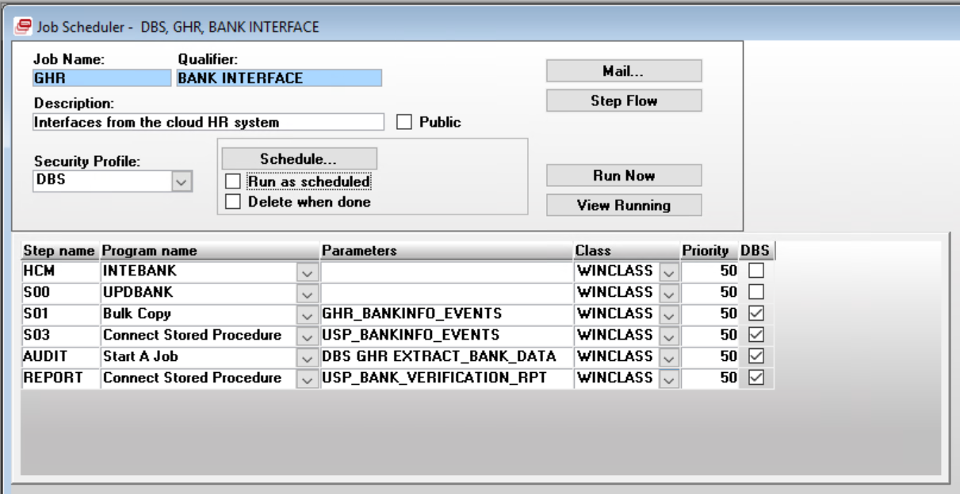

Step 1 – HCM INTEBANK

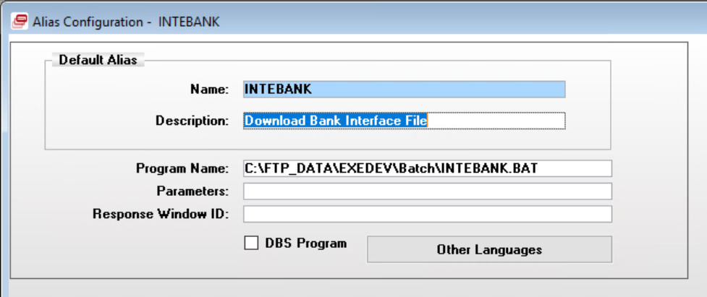

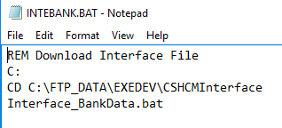
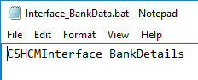

Step 2 – S00 UPDBANK
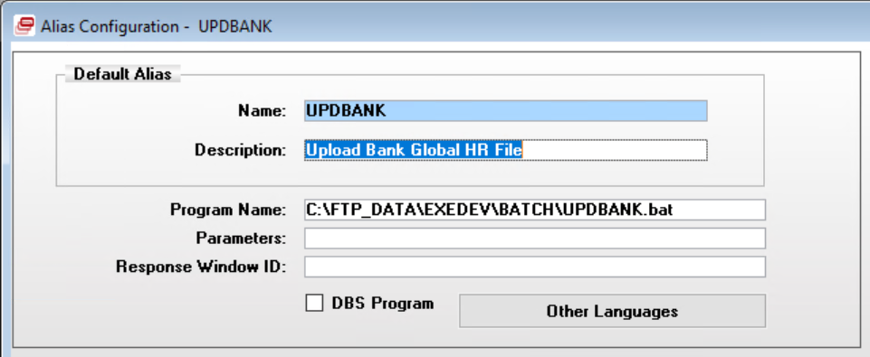

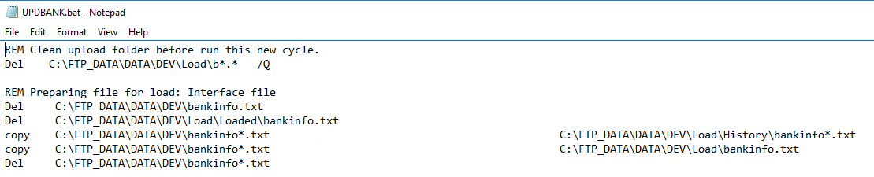

Step 3 – S01 Bulk Copy GHR-BANKINFO_EVENTS
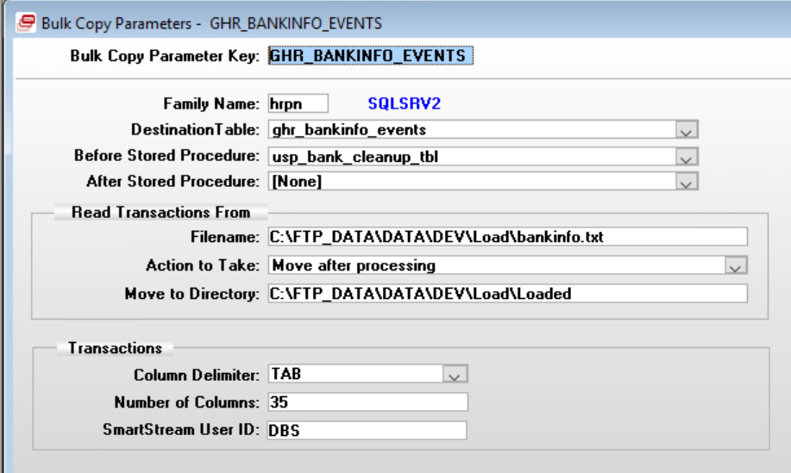

Step 4 – S03 Connect Stored Procedure USP_BANKINFO_EVENTS
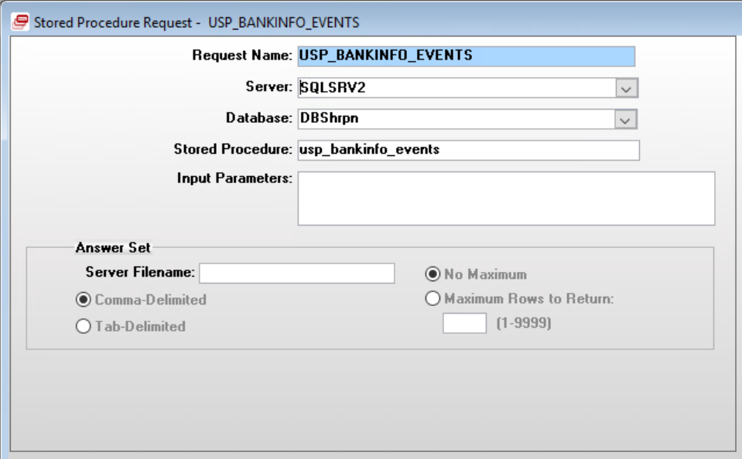

Table Dependencies:
DBSpscb.dbo.psc_step
DBSentp.dbo.batch_parameters
DBShrpn.dbo.ghr_bankinfo_events_aud
DBShrpn.dbo.ghr_bankinfo_events

Procedure Dependencies:
DBShrpn.dbo.usp_ins_bankinfo

Step 5 – AUDIT Start A Job - EXTRACT_BANK_DATA
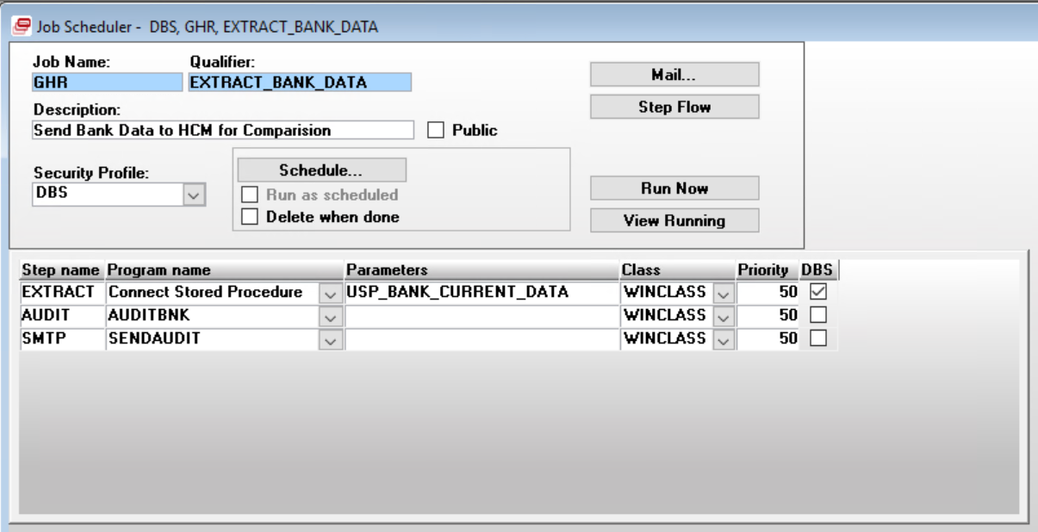

STEP 1 – EXTRACT
Connect Stored Procedure – USP_BANK_CURRENT_DATA
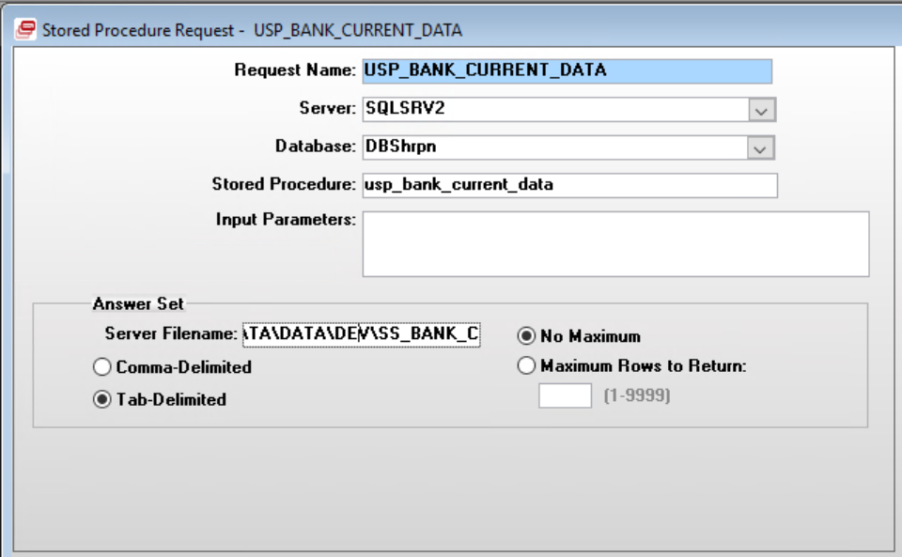

Server Filename: C:\FTP_DATA\DATA\DEV\SS_BANK_C
Table Dependencies:
DBShrpn.dbo.emp_pay_element
DBShrpn.dbo.emp_status

Step 2 – Executable AUDITBNK
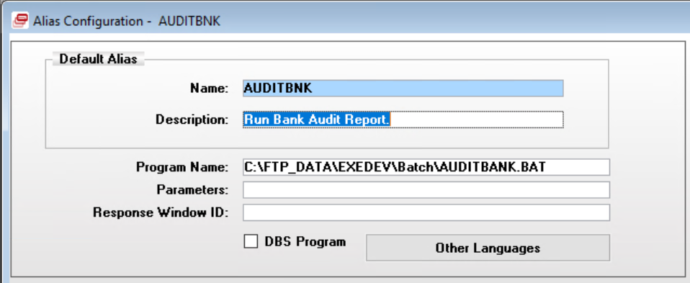

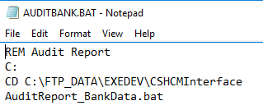

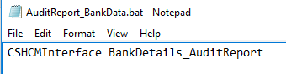

Step 3 – Program SENDAUDIT
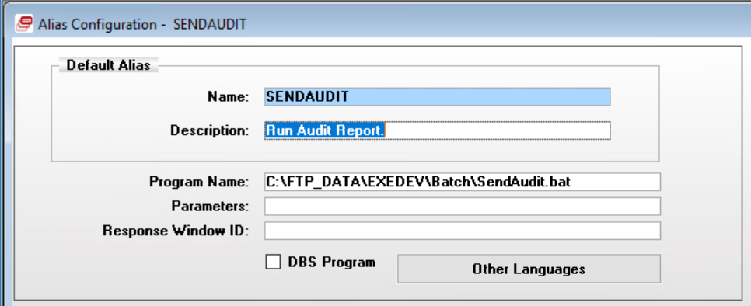

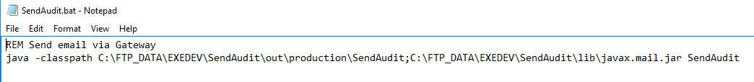

Step 6 – REPORT
Connect Stored Procedure
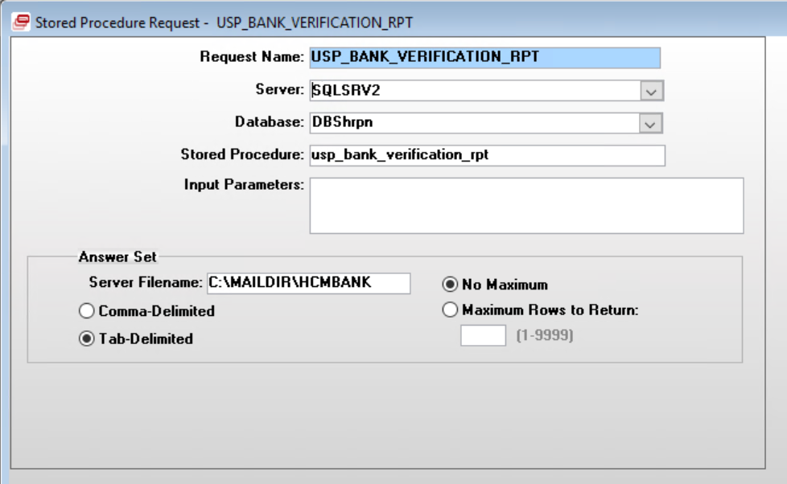

Table Dependencies:
DBShrpn.dbo.ghr_bankinfo_events_aud
DBShrpn.dbo.ghr_email_report2 – (Drops/Creates if table exists)
DBShrpn.dbo.ghr_historical_message

GHR EVENT
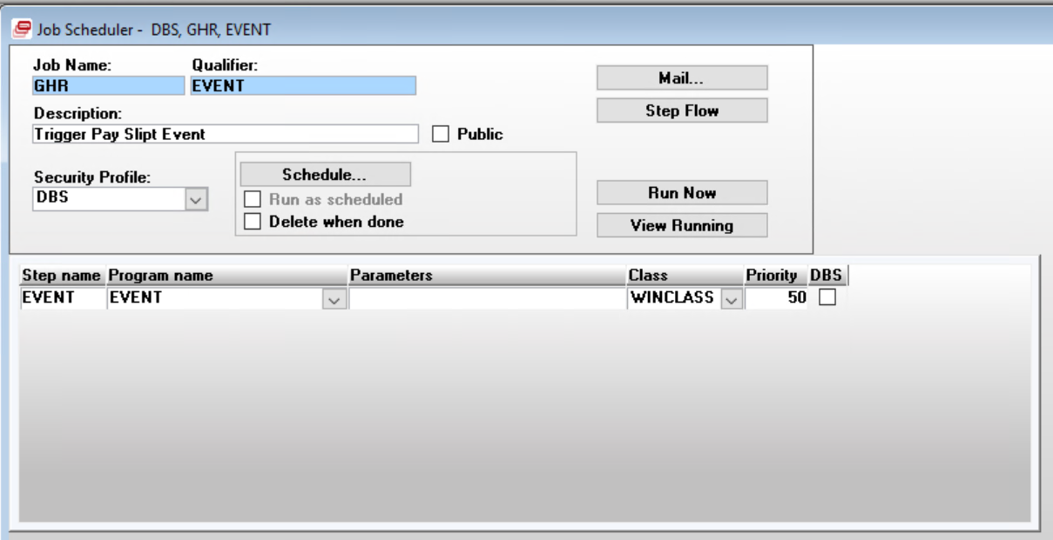

Step 1 – EVENT
Program EVENT

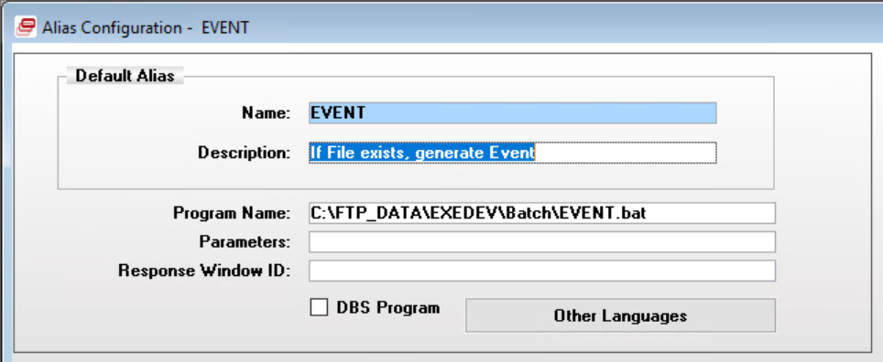

GHR EVENT2
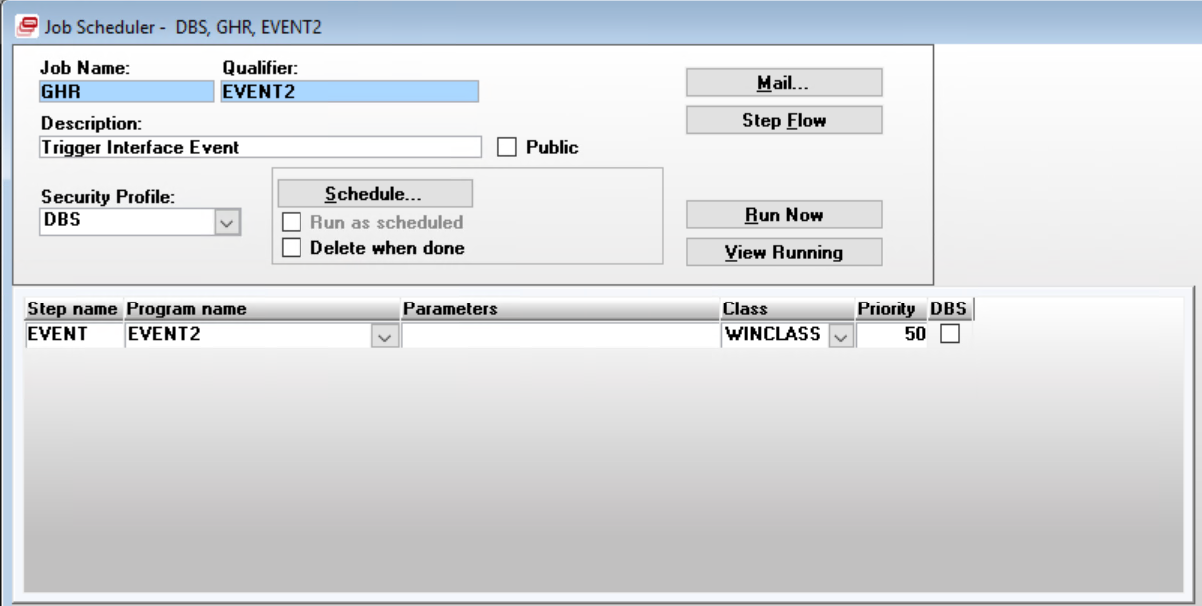

Step 1 – EVENT
Program: EVENT2

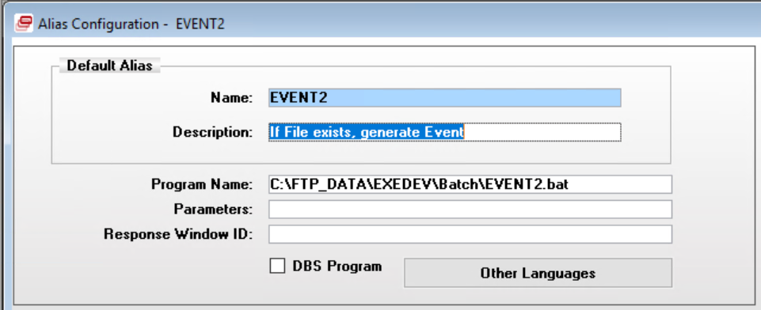

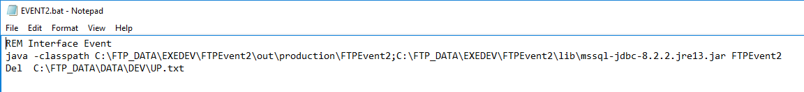

GHR EXTRACT_BANK_DATA
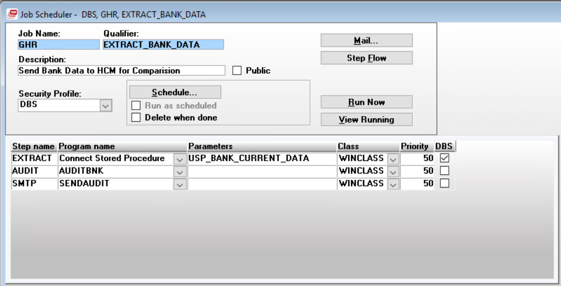

STEP 1 – EXTRACT
Connect Stored Procedure – USP_BANK_CURRENT_DATA

Server Filename: C:\FTP_DATA\DATA\DEV\SS_BANK_C

Table Dependencies:
DBShrpn.dbo.emp_pay_element
DBShrpn.dbo.emp_status

Step 2 – AUDIT
Program AUDITBNK





Step 3 – SMTP
Program SENDAUDIT




GHR EXTRACT_DATA
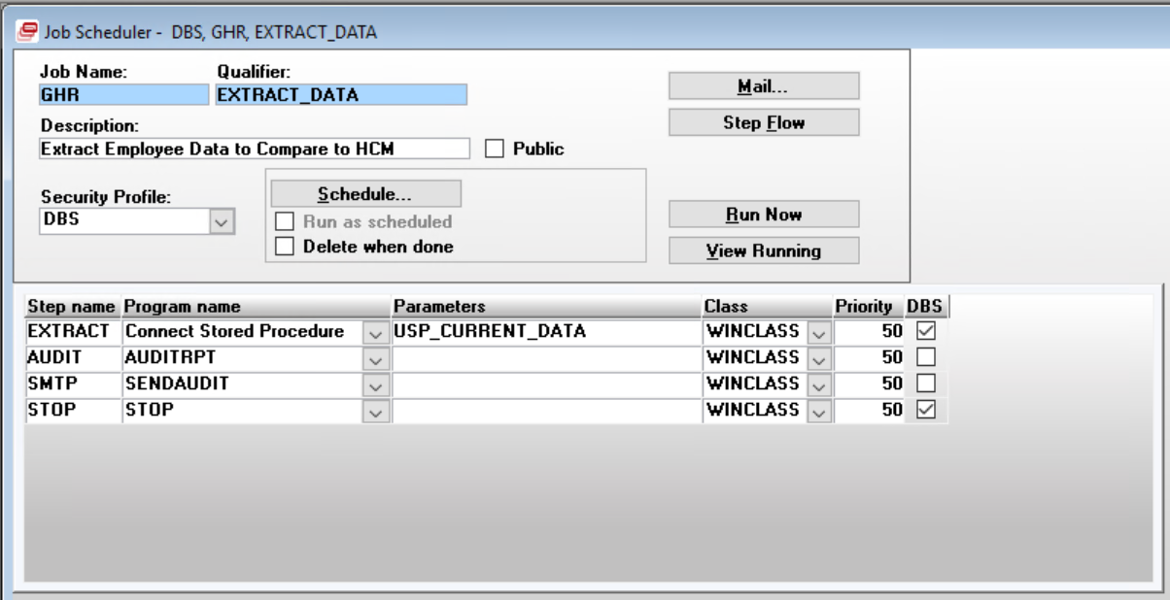

Step 1 – EXTRACT
Connect Stored Procedure USP_CURRENT_DATA
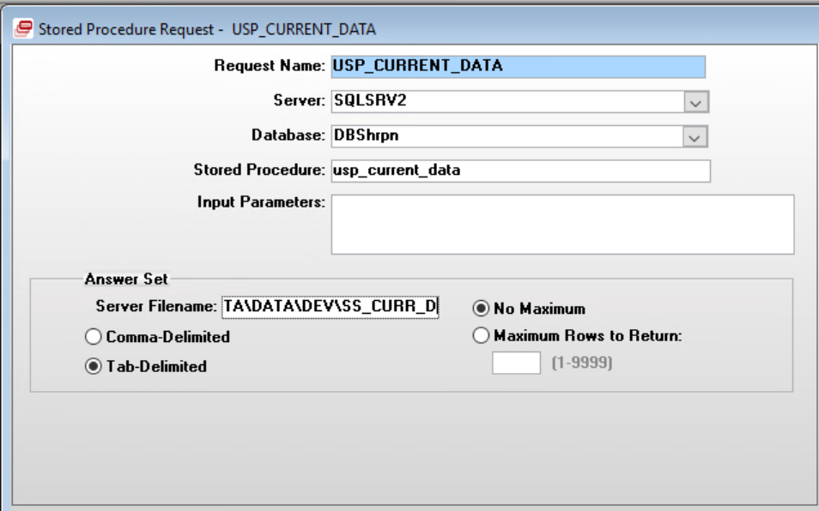
Server Filename: C:\FTP_DATA\DATA\DEV\SS_CURR_D

Table Dependencies:
DBShrpn.dbo.ghr_current_temp1 (Drops/creates if tables exists)
DBShrpn.dbo.employee
DBShrpn.dbo.individual
DBShrpn.dbo.individual_personal
DBShrpn.dbo.emp_employment
DBShrpn.dbo.emp_assignment
DBShrpn.dbo.emp_status
DBShrpn.dbo.pos_title
DBShrpn.dbo.job_title
DBShrpn.dbo.ghr_current_temp2

Step 2 – AUDIT
Program AUDITRPT
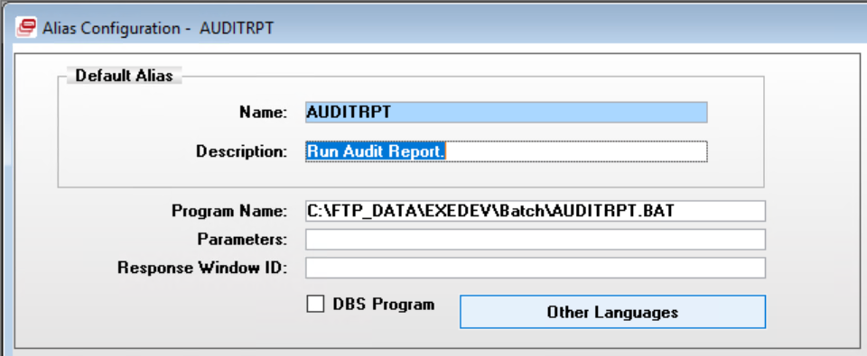

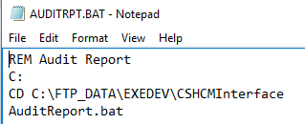
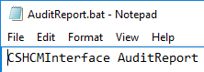

Excel report is saved to C:\FTP_DATA\EXEDEV\CSHCMInterface\AuditReport

Step 3 – SMTP
Program SENDAUDIT
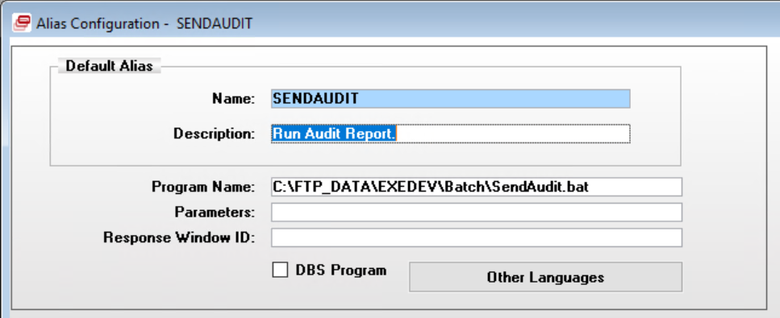



GHR EXTRACT_PE_DATA
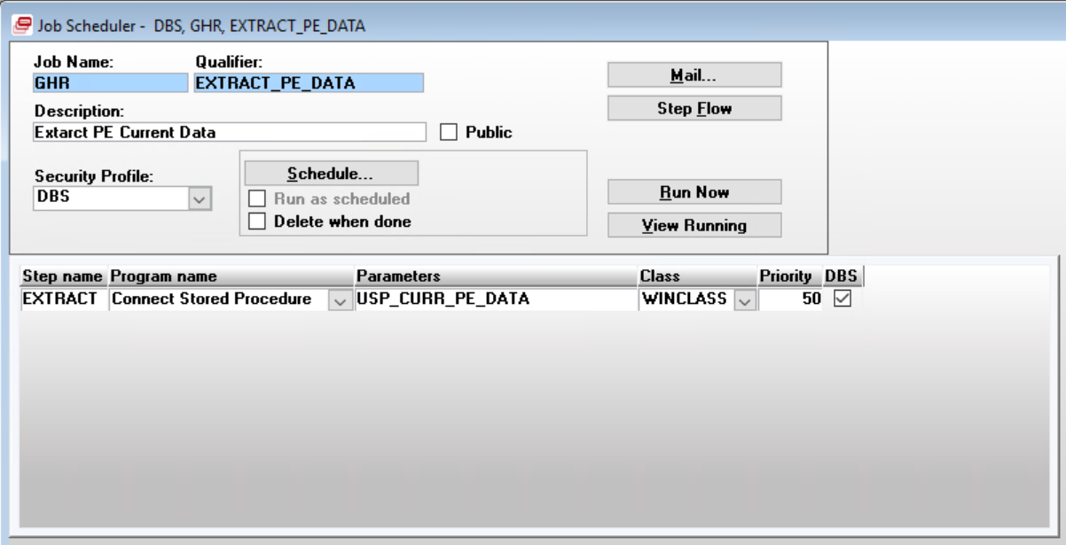

Step 1 – EXTRACT
Connect Stored Procedure USP_CURR_PE_DATA
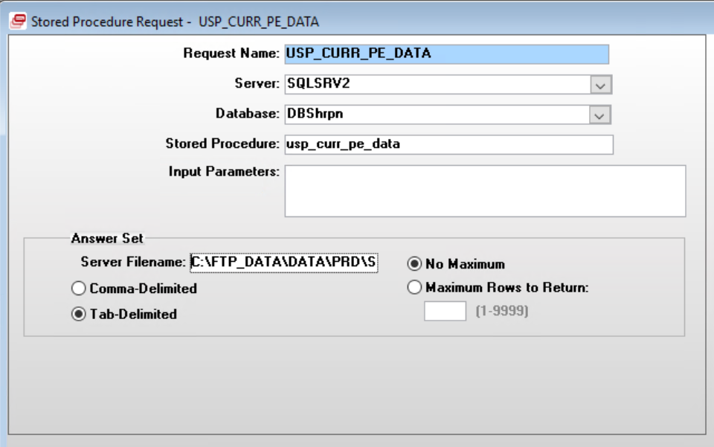
Server Filename: C:\FTP_DATA\DATA\PRD\SS_CURR_P

Table Dependencies:
DBShrpn.dbo.employee
DBShrpn.dbo.individual
DBShrpn.dbo.individual_personal
DBShrpn.dbo.emp_employment
DBShrpn.dbo.emp_assignment
DBShrpn.dbo.emp_status
DBShrpn.dbo.emp_pay_element
DBShrpn.dbo.pay_element

GHR INTERFACES
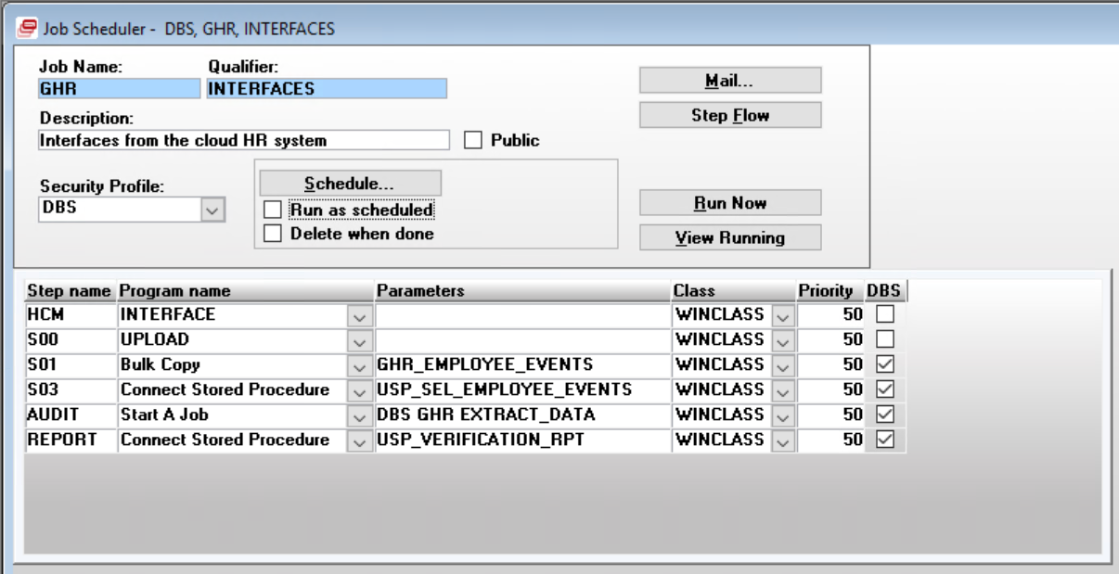

Step 1 – HCM
Program INTERFACE
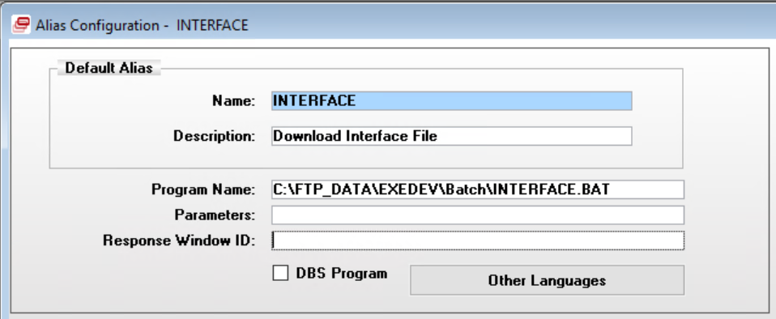

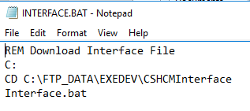
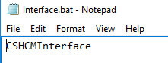

Step 2 – S00
Program UPLOAD
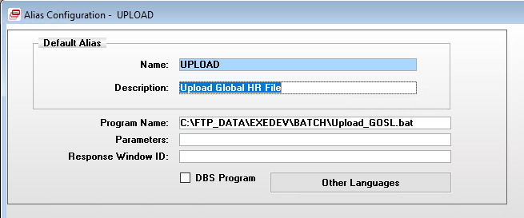

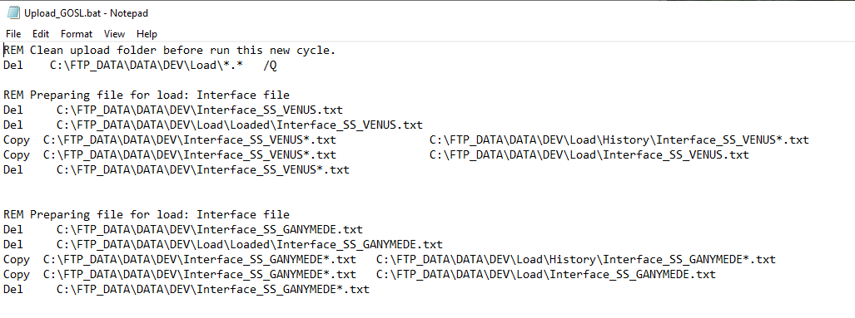

Step 3 – S01 Bulk Copy GHR_EMPLOYEE_EVENTS
Original
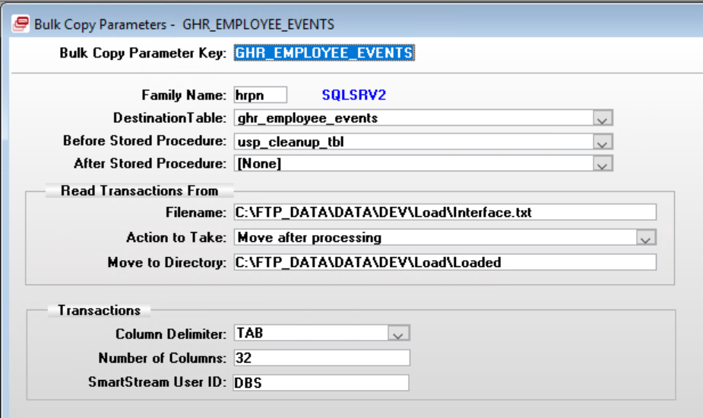

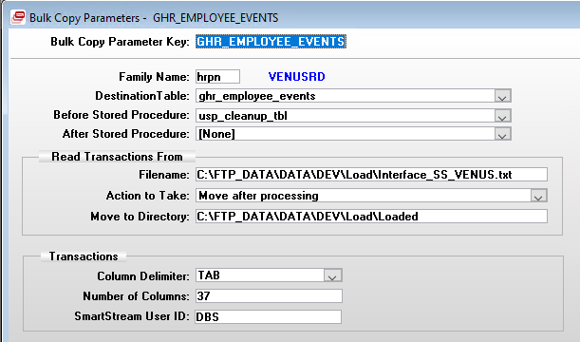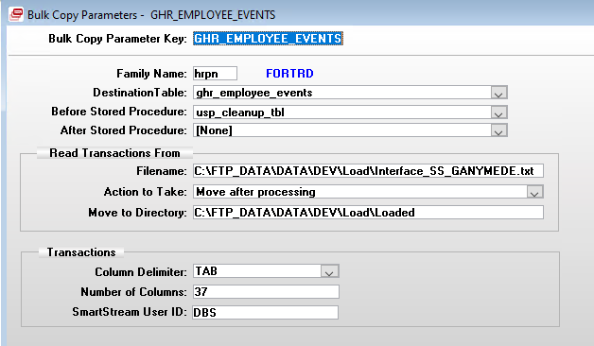

DBShrpn.dbo.ghr_employee_events

Column Name | Data Type
event_id | char(2)
emp_id | char(15)
eff_date | char(10)
first_name | char(25)
first_middle_name | char(25)
last_name | char(30)
empl_id | char(10)
national_id_type_code | char(5)
national_id | char(20)
organization_group_id | char(5)
organization_chart_name | char(64)
organization_unit_name | char(240)
emp_status_classn_code | char(2)
position_title | char(60)
employment_type_code | varchar(70)
annual_salary_amt | char(15)
begin_date | char(10)
end_date | char(10)
pay_status_code | char(1)
pay_group_id | char(10)
pay_element_ctrl_grp_id | char(10)
time_reporting_meth_code | char(1)
employment_info_chg_reason_cd | char(5)
emp_location_code | char(10)
emp_status_code | char(2)
reason_code | char(2)
emp_expected_return_date | char(10)
pay_through_date | char(10)
emp_death_date | char(10)
consider_for_rehire_ind | char(1)
pay_element_id | char(10)
emp_calculation | char(15)
tax_flag | char(1)
nic_flag | char(1)
tax_ceiling_amt | char(15)
labor_grp_code | char(50)
file_source | char(50)

Step 4 – S03 Connect Stored Procedure USP_SEL_EMPLOYEE_EVENTS
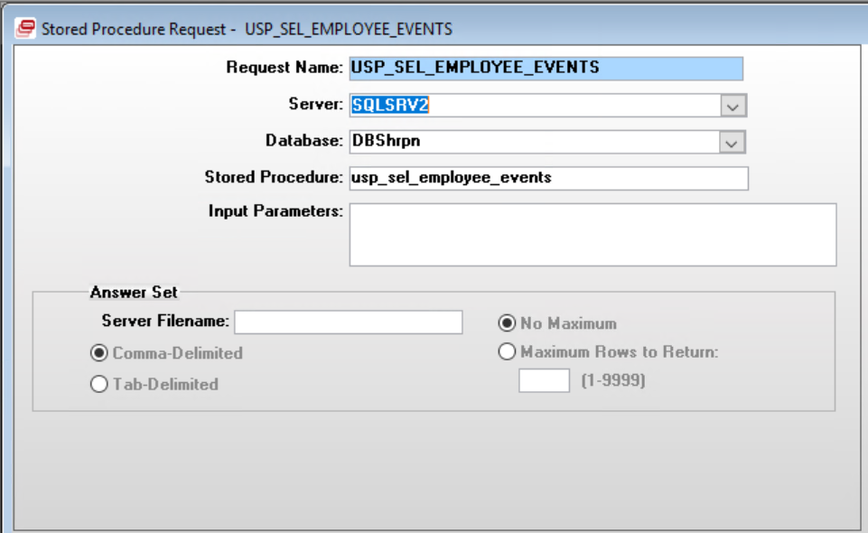

Table Dependencies:
DBSpscb.dbo.psc_step
DBSentp.dbo.batch_parameters
DBShrpn.dbo.ghr_employee_events_aud
DBShrpn.dbo.ghr_employee_events

DBShrpn.dbo.ghr_message_temp_1 (Created/Dropped in procedure)
DBSCOMMON.dbo.message_master

New Hire

Event ID: ‘01’

Stored Procedure Dependencies:
DBShrpn.dbo.usp_ins_new_hire

Tables:
ghr_employee_events_temp1
DBShrpn.dbo.ghr_employee_events_aud
DBShrpn.dbo.ghr_historical_message
dbo.ghr_message_temp_1

Procedures:
DBShrpn.dbo.usp_ins_hemp
DBSpscb.dbo.psp_ins_psc_putmsg_2

Error Code | Message Master | dbo.ghr_message_temp_1
U00000 | < NEW HIRE SECTION (1) >
U00001 | Total Global HR New Hire: @1
U00009 | < BEGINNING OF ERROR MESSAGES: >
U00011 | Blank
U00001 | Total Global HR New Hire: @1
U00003 | Total nbr of employees that already exist: @1
U00005 | Employer (@1) does not exist for employee: @2 - defaulting 99999 | Y
U00046 | NIS nbr is blank - defaulting 99999 for employee @1 | NOT IN FINAL LOG
U00006 | This employee, @1,NIS nbr already exists - defaulting 99999. NIS nbr is: @2 | Y
U00007 | NIS nbr was blank for employee, @1 - defaulting 99999 | Y
U00008 | Unit name (@1) was missing for employee, @2 - defaulting 999999 | Y
U00031 | Pay Element Group was blank for employee, @1 - defaulting 99999 | Y
U00020 | Pay Group, @1, does not exists for employee, @2 - defaulting 99999 | Y
U00021 | Pay Element Control Group, @1 does not exists for employee,@2 -defaulting 99999 | Y
U00048 | After April 1, 2023,Pay Group, @1, must be semi-monthly. | NOT IN FINAL LOG
U00011 | Blank
U00010 | <ENDING OF ERROR MESSAGES: >
U00011 | Blank

Salary Change

Event ID: ‘02’

GOSL – SALARY CHANGES SECTION NOT USED
DBShrpn.dbo.usp_ins_salary_change
DBSpscb.dbo.psp_ins_psc_putmsg_2

Error Code | Message Master | dbo.ghr_message_temp_1
U00014 | < SALARY CHANGE SECTION (02) > | N
U00009 | < BEGINNING OF ERROR MESSAGES: > | N
U00011 | BLANK (Inserts blank text in logging table) | N
U00015 | Total Global HR Salary Changes: @1
U00012 | Employee, @1, does not exists | Y
U00020 | Pay Group, @1, does not exists for employee, @2 - defaulting 99999 | Y
U00027 | The new effective date, @1 , for employee, @2, must be greater than the current effective date | Y
U00035 | Salary cannot be blank for salary change record. Employee ID: @1 | Y
U00041 | Salary cannot be zeroed for a Salary Change for employee: @1 | Y
U00011 | Blank | N
U00010 | <ENDING OF ERROR MESSAGES: > | N
U00011 | Blank

Transfer

Event ID: ‘03’

DBShrpn.dbo.usp_perform_transfer
DBShrpn.dbo.usp_upd_hrpn_02_trn
DBShrpy.dbo.usp_ins_hpep_02_trn
DBSpscb.dbo.psp_ins_psc_putmsg_2

Error Code | Message Master | dbo.ghr_message_temp_1
U00017 | < EMPLOYEE TRANSFER SECTION (3) > | N
U00009 | < BEGINNING OF ERROR MESSAGES: > | N
U00011 | BLANK (Inserts blank text in logging table) | N
U00018 | Total Global HR Employee Transfer: @1 | N
U00012 | Employee, @1, does not exists | Y
U00027 | The new effective date, @1, for employee, @2, must be greater than the current effective date. | Y
U00036 | Transfer date must be greater than default position effective date. Employee ID: @1 | Y
U00034 | Cannot transfer an employee to the same employer. New Employer is @1 - By passing this employee: @2 | Y
U00038 | Existing payments have not been updated into the accumulator for this employee: @1 | Y
U00039 | Employer ID, @1, does not exist - bypassing record. | Y
U00040 | Pay Element Control Group cannot be blank for employee, @1, - defaulting to 99999. | Y
U00044 | Cannot transfer an employee, @1, to a pensioner employer | Y
U00045 | Terminated employee, @1, cannot be transferred | Y
U00011
U00010 | < ENDING OF ERROR MESSAGES: >
U00011

Name Change

Event ID: ‘04’

DBShrpn.dbo.usp_ins_name_change
DBSpscb.dbo.psp_ins_psc_putmsg_2

Error Code | Message Master | dbo.ghr_message_temp_1
U00013 | < NAME CHANGE SECTION (4) > | N
U00009 | < BEGINNING OF ERROR MESSAGES: >
U00011
U00016 | Total Global HR Name Changes: @1
U00013 | < NAME CHANGE SECTION (4) >
U00012 | Employee, @1, does not exists
U00011
U00010 | <ENDING OF ERROR MESSAGES: >
U00011

Status Change

Event ID: ‘05’

DBShrpn.dbo.usp_ins_status_change
DBShrpn.dbo.usp_upd_hmpl_rehire
DBShrpn.dbo.usp_ins_hpcg_hepy
DBShrpn.dbo.usp_upd_hmpl_inactivate
DBShrpn.dbo.usp_upd_hmpl_terminate
DBShrpn.dbo.usp_upd_hmpl_reactivate
DBSpscb.dbo.psp_ins_psc_putmsg_2

Error Code | Message Master | dbo.ghr_message_temp_1
U00023 | < STATUS CHANGE SECTION (5) > | N
U00009 | < BEGINNING OF ERROR MESSAGES: > | N
U00011 |  | N
U00019 | Total Global HR Status Changes: @1 | N
U00005 | Employer (@1) does not exist for employee: @2 - defaulting to 99999. | Y
U00012 | Employee, @1, does not exists. | Y
U00024 | Cannot Inactivate an employee, @1, if the current status is not active. | Y
U00025 | Cannot Reactivate an employee, @1, if the current status is not inactive. | Y
U00026 | The current status is @1. To Reactivate an employee, @2, the current status must be inactive. | Y
U00032 | The rehire date must be greater than the termination date for employee, @1. | Y
U00033 | The Reactivation date must be greater than the inactivation date - By passing the employee: @1 | Y
U00022 | The current status is @1. Cannot rehire an employee, @2, without a current terminated status. | Y
U00036 | Transfer date must be greater than default position effective date for employee, @1. | Y
U00037 | New Status Effective date must be greater than current effective date for employee, @1. | Y
U00042 | Cannot terminate employee, @1, if the current status is not active or inactive. | Y
U00043 | Rehire date must be greater than current employee employment effective date for employee: @1. | Y
U00011
U00010 | <ENDING OF ERROR MESSAGES: >
U00011

Pay Allowances

Event ID: ‘06’

DBShrpn.dbo.usp_ins_pay_element
DBShrpn.dbo.usp_ins_hepy_insert
DBSpscb.dbo.psp_ins_psc_putmsg_2

Error Code | Message Master | dbo.ghr_message_temp_1
U00028 | < PAY ELEMENT SECTION (6) >
U00009 | < BEGINNING OF ERROR MESSAGES: >
U00011
U00029 | Total Global HR Pay Elements Read: @1'
U00012 | Employee, @1, does not exists.
U00027 | The new effective date, @1, for employee, @2, must be greater than the current effective date.
U00030 | The Begin Date, @1, cannot be greater than the pay through date for employee, @2.
U00039 | Employer ID, @1, does not exist - bypassing record.
U00047 | The stop date must be the same or later than the employee pay element effective date for employee, @1.
U00101 | Invalid pay element amount, @1, for employee, @2, and pay element id, @3.
U00011
U00010 | <ENDING OF ERROR MESSAGES: >
U00011

Update Pay Group

Event ID: ‘08’

DBShrpn.dbo.usp_ins_pay_group
DBSpscb.dbo.psp_ins_psc_putmsg_2

Error Code | Message Master | dbo.ghr_message_temp_1
U00115 | < PAY GROUP SECTION (8) >
U00009 | < BEGINNING OF ERROR MESSAGES: >
U00011
U00012 | Employee, @1, does not exists.
U00027 | The new effective date, @1, for employee, @2, must be greater than the current effective date.
U00102 | Invalid date value from HCM, ''@1'', for employee, @2, and event id, @3.
U00105 | Total Pay Group Changes: @1
U00106 | New pay group, (@1) is same as current pay group, for employee @2 - bypassing record.
U00119 | Bypassing @1 record since employee (@2) has either a new hire, transfer, or status change event in this extract.
U00011
U00010 | <ENDING OF ERROR MESSAGES: >
U00011

Update Labor Group

Event ID: ‘09’

DBShrpn.dbo.usp_ins_labor_group
DBSpscb.dbo.psp_ins_psc_putmsg_2

Error Code | Message Master | dbo.ghr_message_temp_1
U00107 | < LABOR GROUP SECTION (9) >
U00009 | < BEGINNING OF ERROR MESSAGES: >
U00011
U00012 | Employee, @1, does not exists.
U00020 | Invalid Pay Group ID, (@1), for employee, @2 - defaulting to 99999.
U00027 | The new effective date, @1, for employee, @2, must be greater than the current effective date.
U00102 | Invalid date value from HCM, ''@1'', for employee, @2, and event id, @3.
U00108 | Total Labor Group Changes: @1
U00109 | New labor group, (@1) is same as current labor group, for employee @2 - bypassing record.
U00110 | New labor group is blank, for employee @2 - bypassing record.
U00111 | Invalid Labor Group Code, (@1), for employee, @2 - bypassing record.
U00119 | Bypassing @1 record since employee (@2) has either a new hire, transfer, or status change event in this extract.
U00011
U00010 | <ENDING OF ERROR MESSAGES: >
U00011

Update Position Title

Event ID: ‘10’

DBShrpn.dbo.usp_ins_position_title
DBSpscb.dbo.psp_ins_psc_putmsg_2

Error Code | Message Master | dbo.ghr_message_temp_1
U00115 | <POSITION TITLE SECTION (10)>
U00009 | < BEGINNING OF ERROR MESSAGES: >
U00011
U00012 | Employee, @1, does not exists.
U00027 | The new effective date, @1, for employee, @2, must be greater than the current effective date.
U00102 | Invalid date value from HCM, ''@1'', for employee, @2, and event id, @3.
U00116 | Total Position Title Changes: @1
U00117 | New position title, (@1) is same as current position title, for employee @2 - bypassing record.
U00118 | New position title is blank, for employee @2 - bypassing record.
U00119 | Bypassing @1 record since employee (@2) has either a new hire, transfer, or status change event in this extract.
U00011
U00010 | <ENDING OF ERROR MESSAGES: >
U00011

Step 5 – AUDIT
Start A Job DBS GHR EXTRACT_DATA

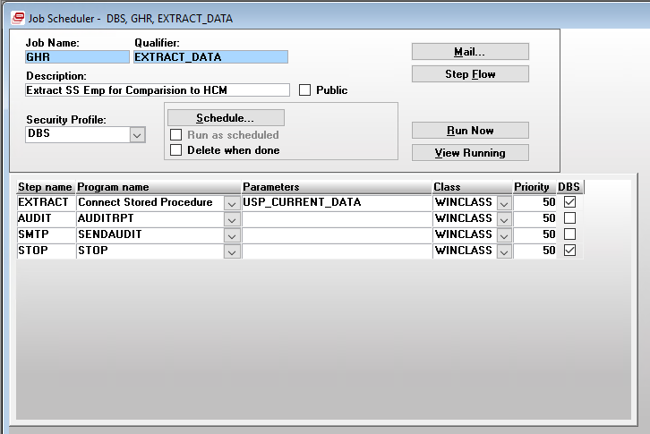

Step 6 – REPORT
Connect Stored Procedure USP_VERIFICATION_RPT

Grenada
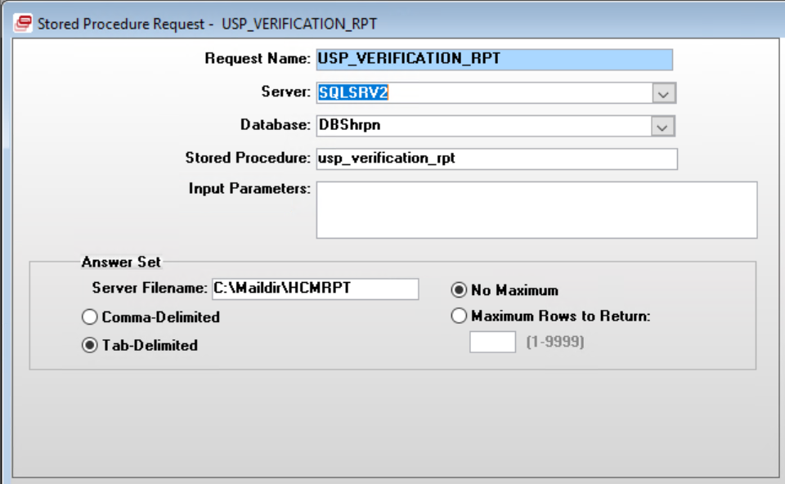

GOSL – VENUS and GANYMEDE

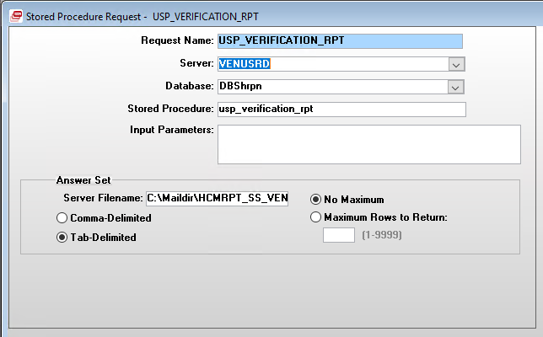
Server Filename: C:\Maildir\HCMRPT_SS_VENUS

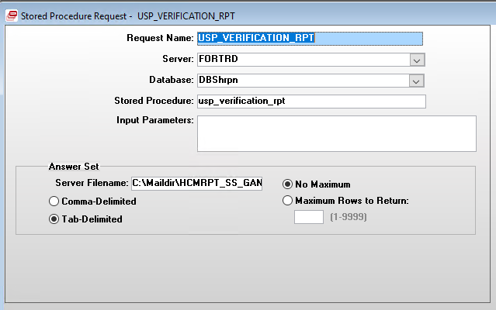
Server Filename: C:\Maildir\HCMRPT_SS_GANYMEDE

Table Dependencies:
DBShrpn.dbo.ghr_employee_events_aud
[dbo].[ghr_email_report] (Drops/Creates if table exists)
[DBShrpn].[dbo].[ghr_historical_message]

GHR PAYSLIP_INTERFACE
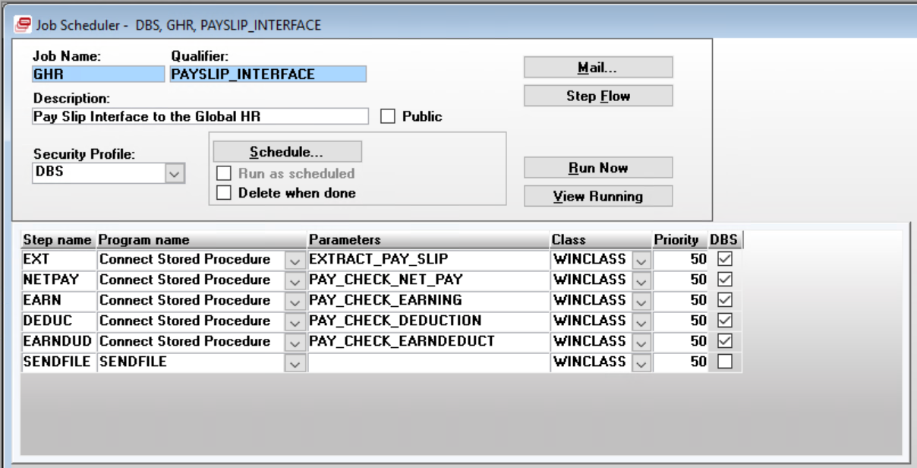

Step 1 – EXT
Connect Stored Procedure EXTRACT_PAY_SLIP
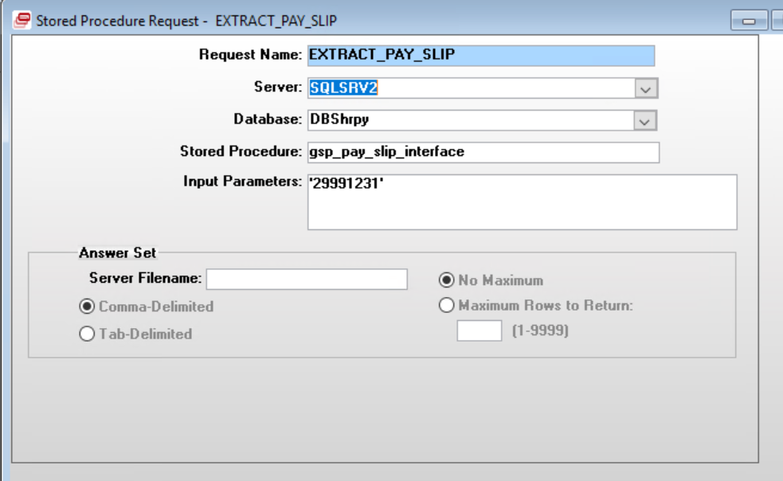

Table Dependencies:
DBShrpy.dbo.emp_pmt
DBShrpy.dbo.ghr_payment_temp
DBShrpy.dbo.ghr_pay_period_temp
DBShrpy.dbo.ghr_emp_pmt_sum
DBShrpy.dbo.ghr_emp_pmt_pay_element_detail_sum
DBShrpy.dbo.ghr_emp_pmt_sum
DBShrpy.dbo.ghr_emp_pmt_ext
DBShrpy.dbo.ghr_emp_pmt_pay_element_detail_ext

Stored Procedure Dependencies:
DBShrpy.dbo.usp_payslip_ext

Note: Procedure does not exist in SSI environment

Step 2 – NETPAY
Connect Stored Procedure PAY_CHECK_NET_PAY
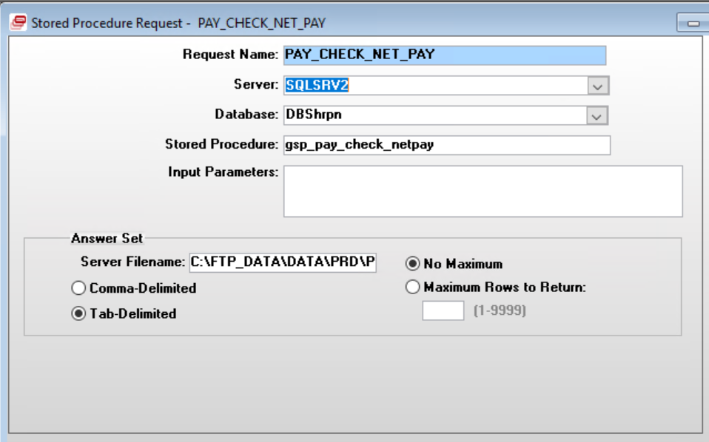

Server Filename: C:\FTP_DATA\DATA\PRD\PSNETPAY

Table Dependencies:
DBShrpn.dbo.ghr_emp_pmt_sumn_temp
DBSbank.dbo.pmt_ref_ctrl
DBShrpy.dbo.emp_pmt_disbursal_detail

Step 3 – EARN
Connect Stored Procedure PAY_CHECK_EARNING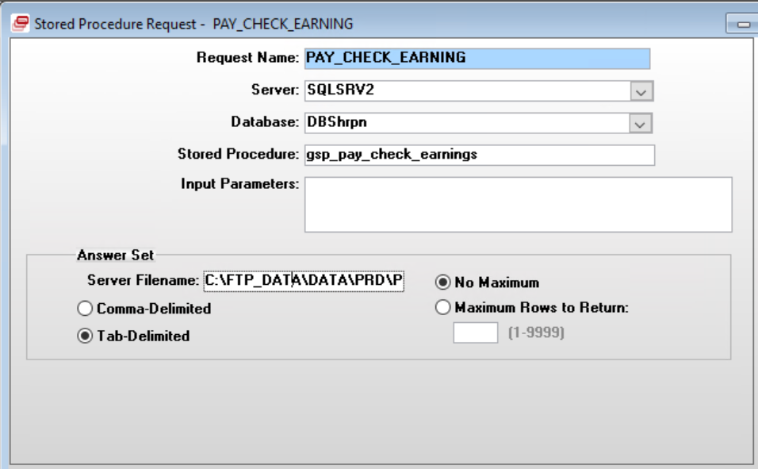

Server Filename: C:\FTP_DATA\DATA\PRD\PSEARN
Table Dependencies:
DBShrpn.dbo.ghr_earnings_temp
DBShrpy.dbo.ghr_emp_pmt_pay_element_detail_sum
DBShrpn.dbo.ghr_emp_pmt_sumn_temp

Step 4 – DEDUC
Connect Stored Procedure PAY_CHECK_DEDUCTION
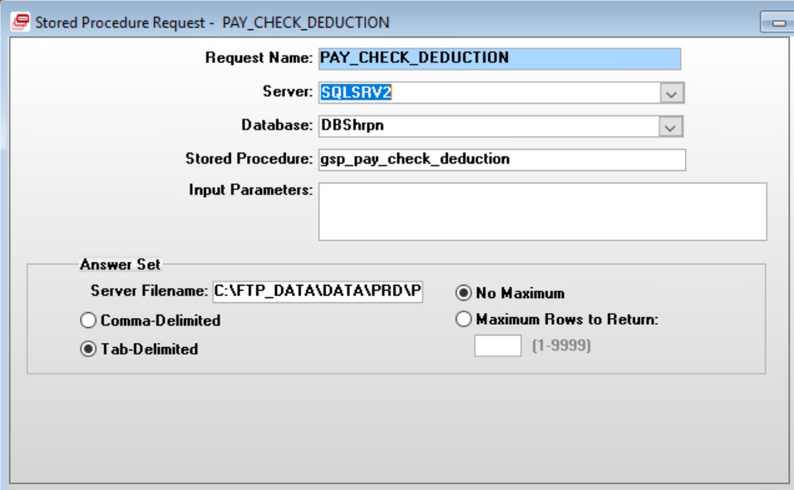

Server Filename: C:\FTP_DATA\DATA\PRD\PSDEDUCT
Table Dependencies:
DBShrpn.dbo.ghr_deduction_temp
DBShrpn.dbo.ghr_emp_pmt_sumn_temp
DBShrpy.dbo.ghr_emp_pmt_pay_element_detail_sum

Step 5 – EARNDUD
Connect Stored Procedure PAY_CHECK_EARNDEDUCT
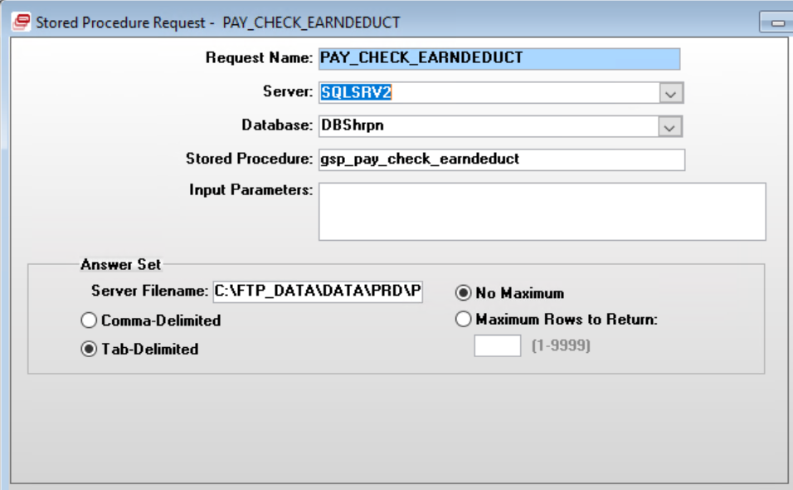

Server Filename: C:\FTP_DATA\DATA\PRD\PSEARNDED
Table Dependencies:
DBShrpy.dbo.ghr_emp_pmt_pay_element_detail_sum
DBShrpn.dbo.ghr_emp_pmt_sumn_temp

Step 6 – SENDFILE
Program SENDFILE
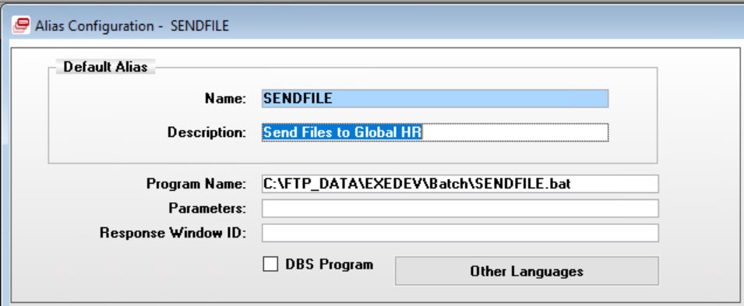

GHR RUN_EVENT
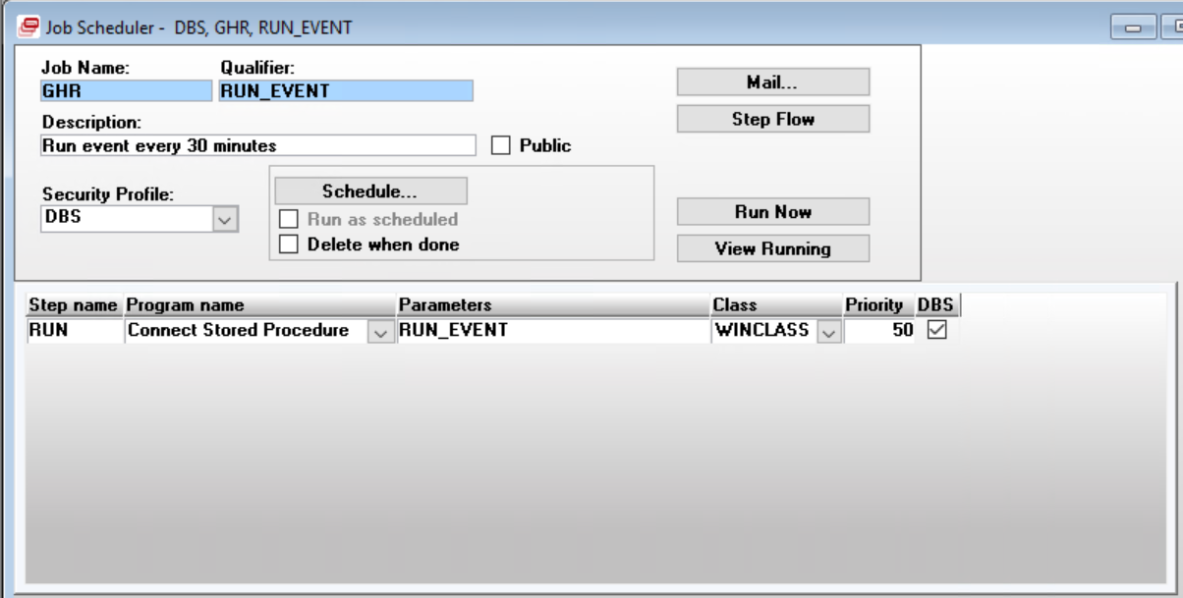

Step 1 – RUN
Connect Stored Procedure: RUN_EVENT
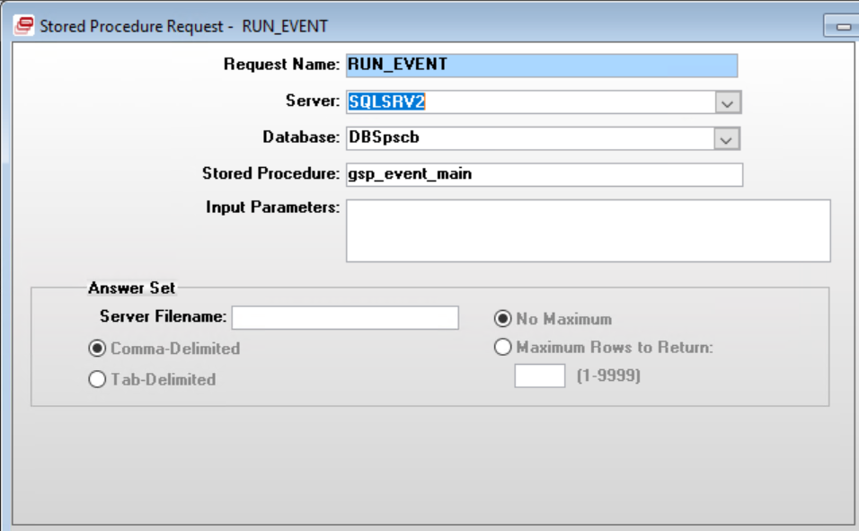

Note: Procedure usp_event_main does not exist in SSI environment

GHR SRV_TO_SRV_COPY
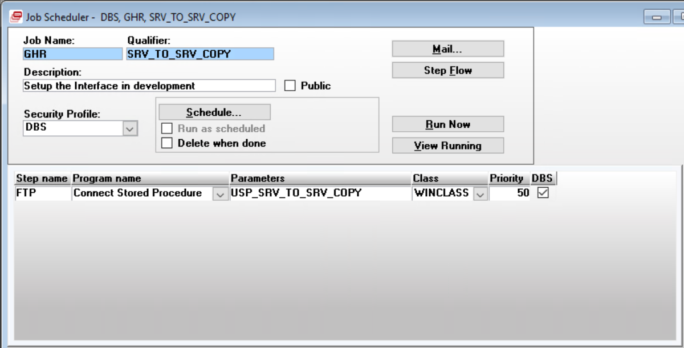

Step 1 – FTP
Connect Stored Procedure: USP_SRV_TO_SRV_COPY

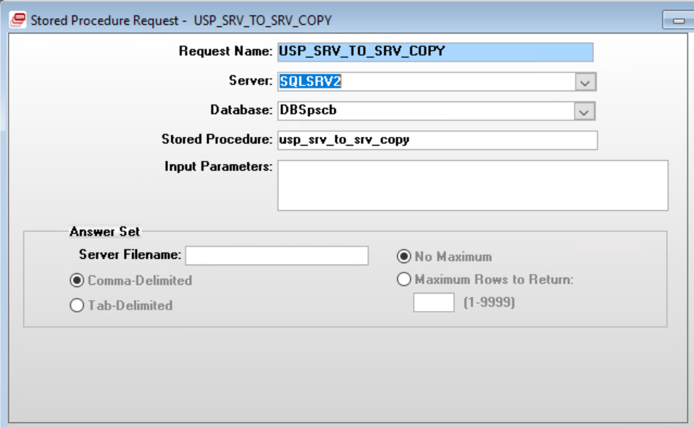

Note: Procedure usp_event_main does not exist in SSI environment.

GHR VERIFICATION_0000
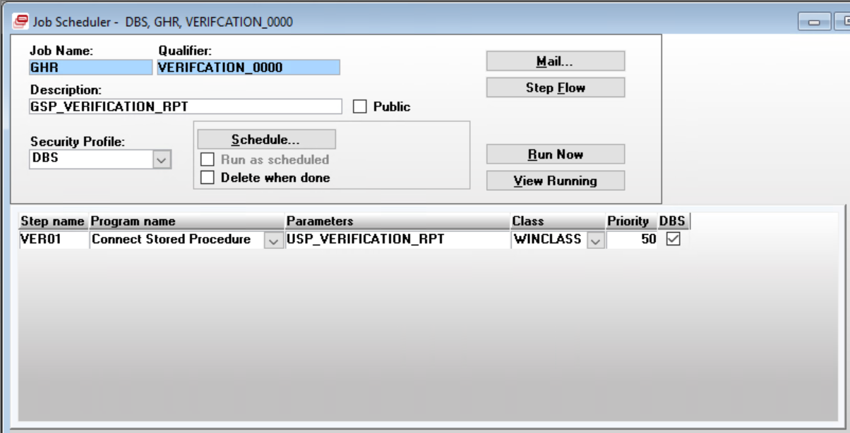

Step 1 – VER01
Connect Stored Procedure: USP_VERIFICATION_RPT

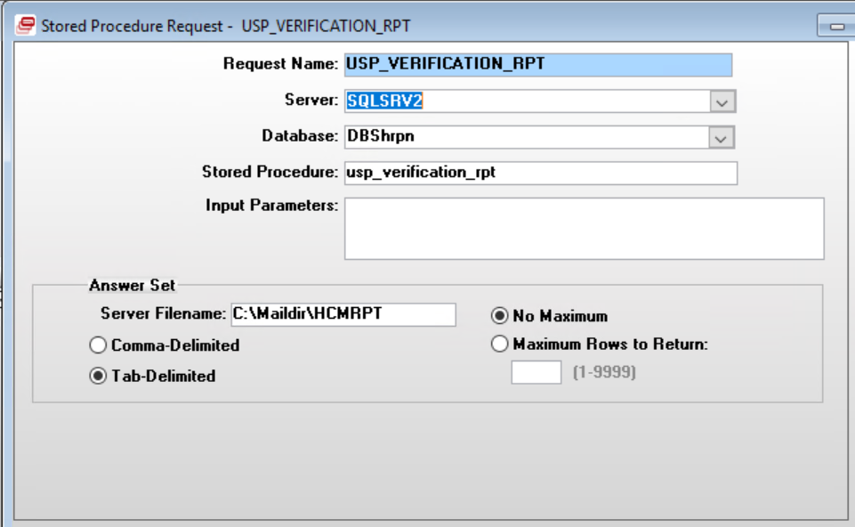

Table Dependencies:
DBShrpn.dbo.ghr_employee_events_aud
DBShrpn.dbo.ghr_email_report
DBShrpn.dbo.ghr_historical_message

